**1.Write a c program for linked list**

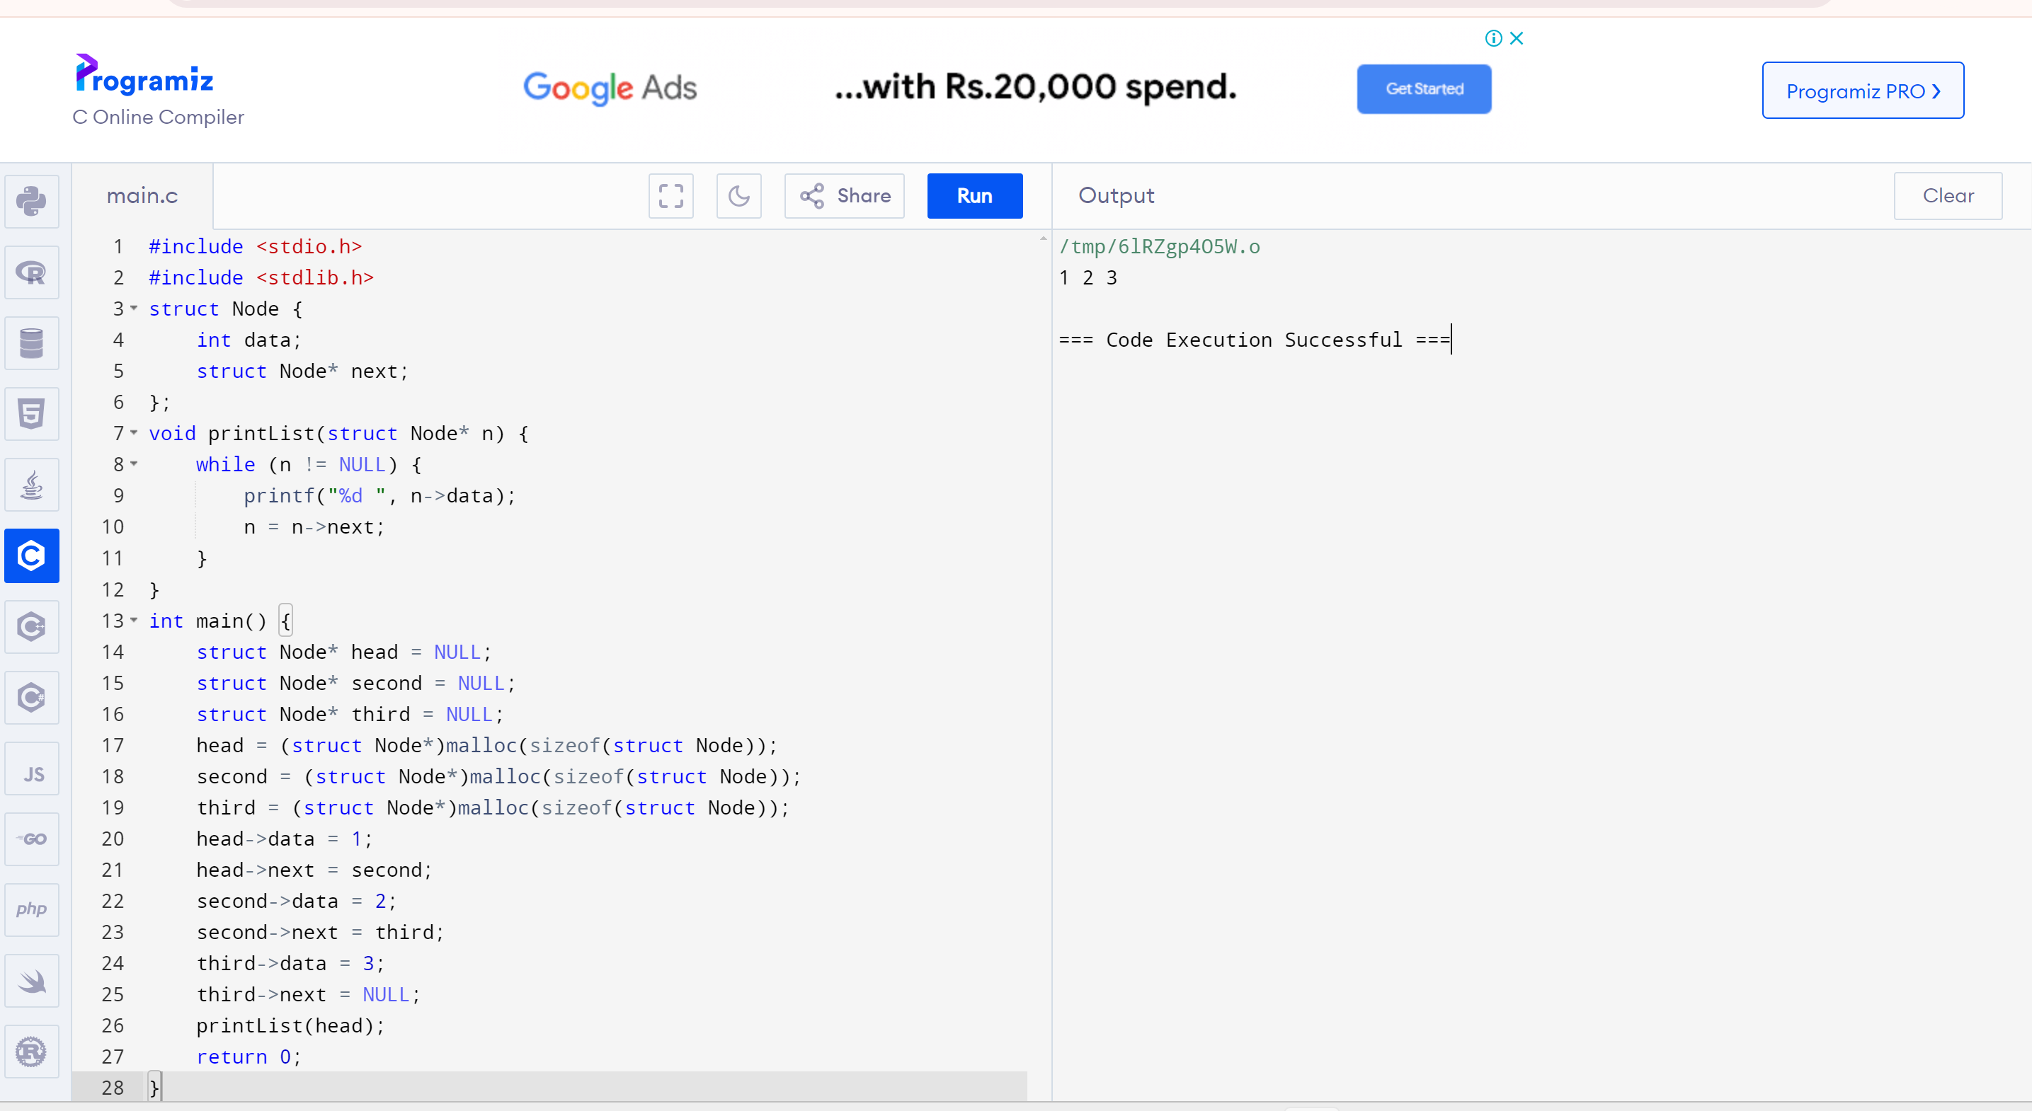

**2.Write a c program for single linked list**

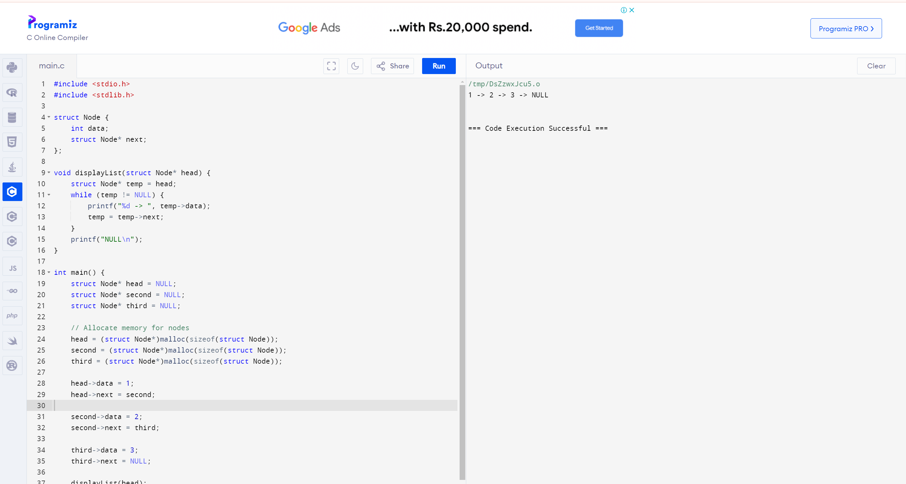

**3.Write a c program for double linked list**

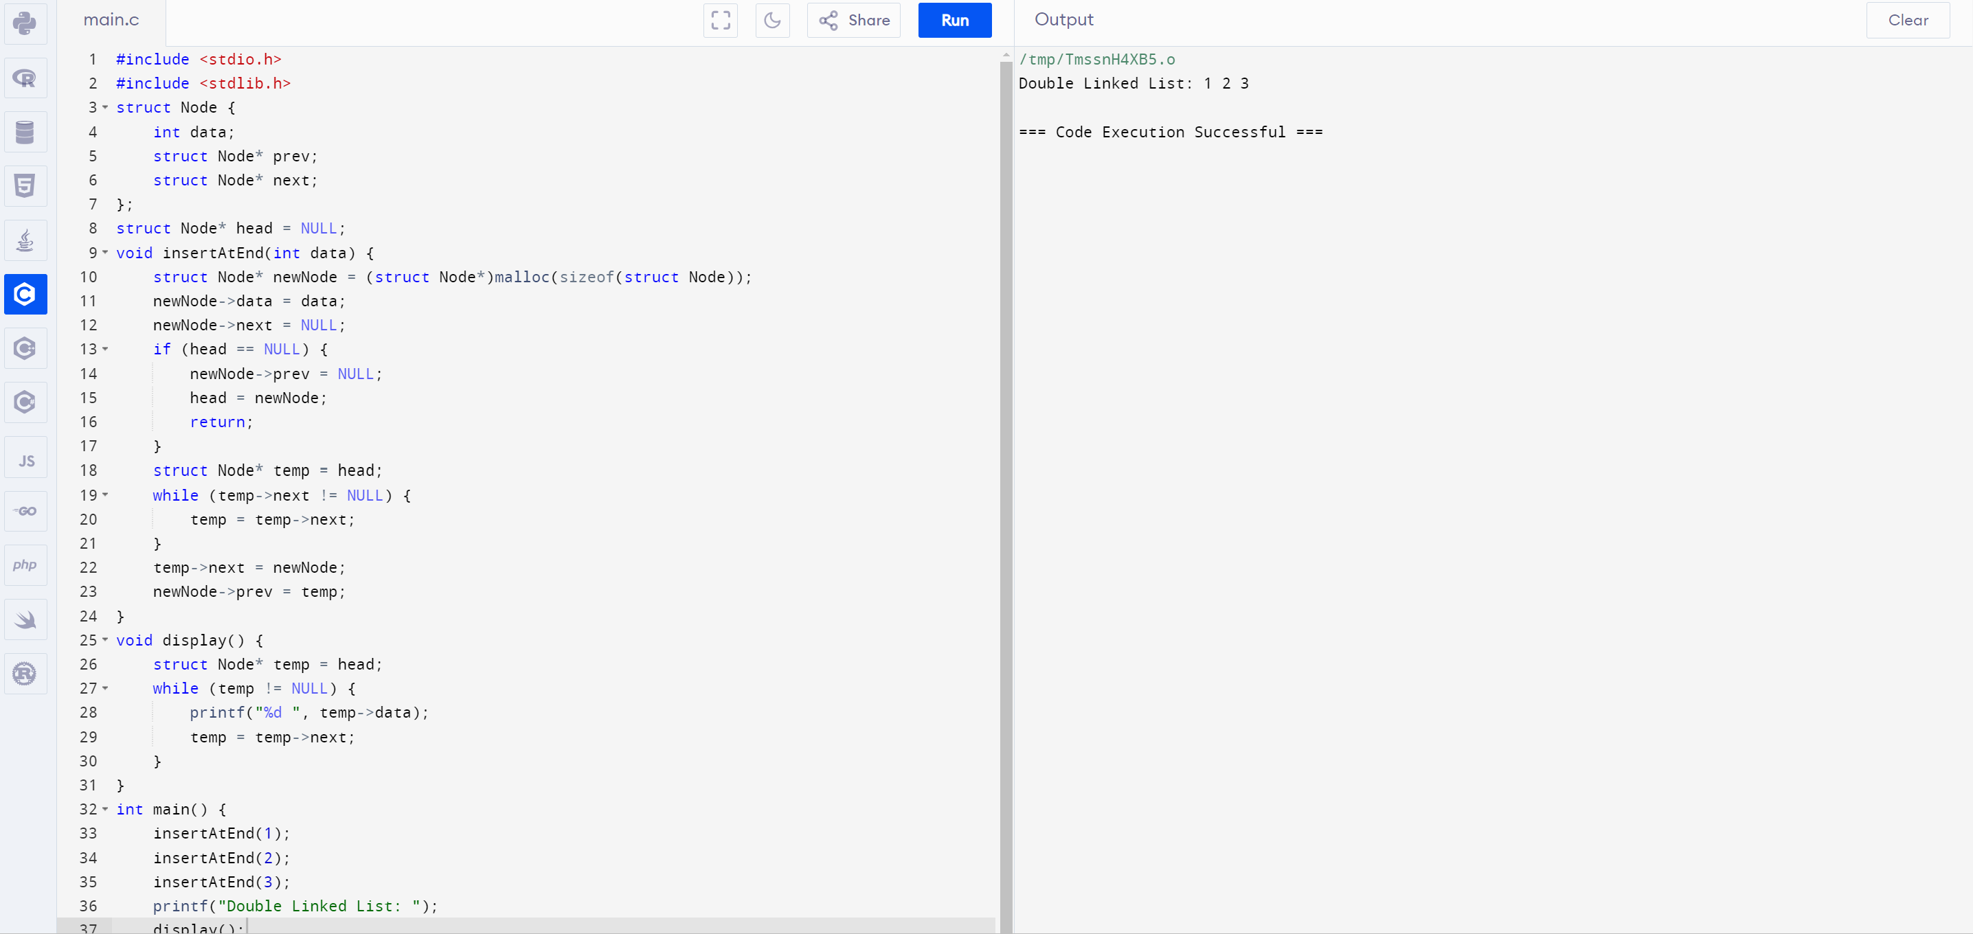

**4.Write a c program to circular linked list**

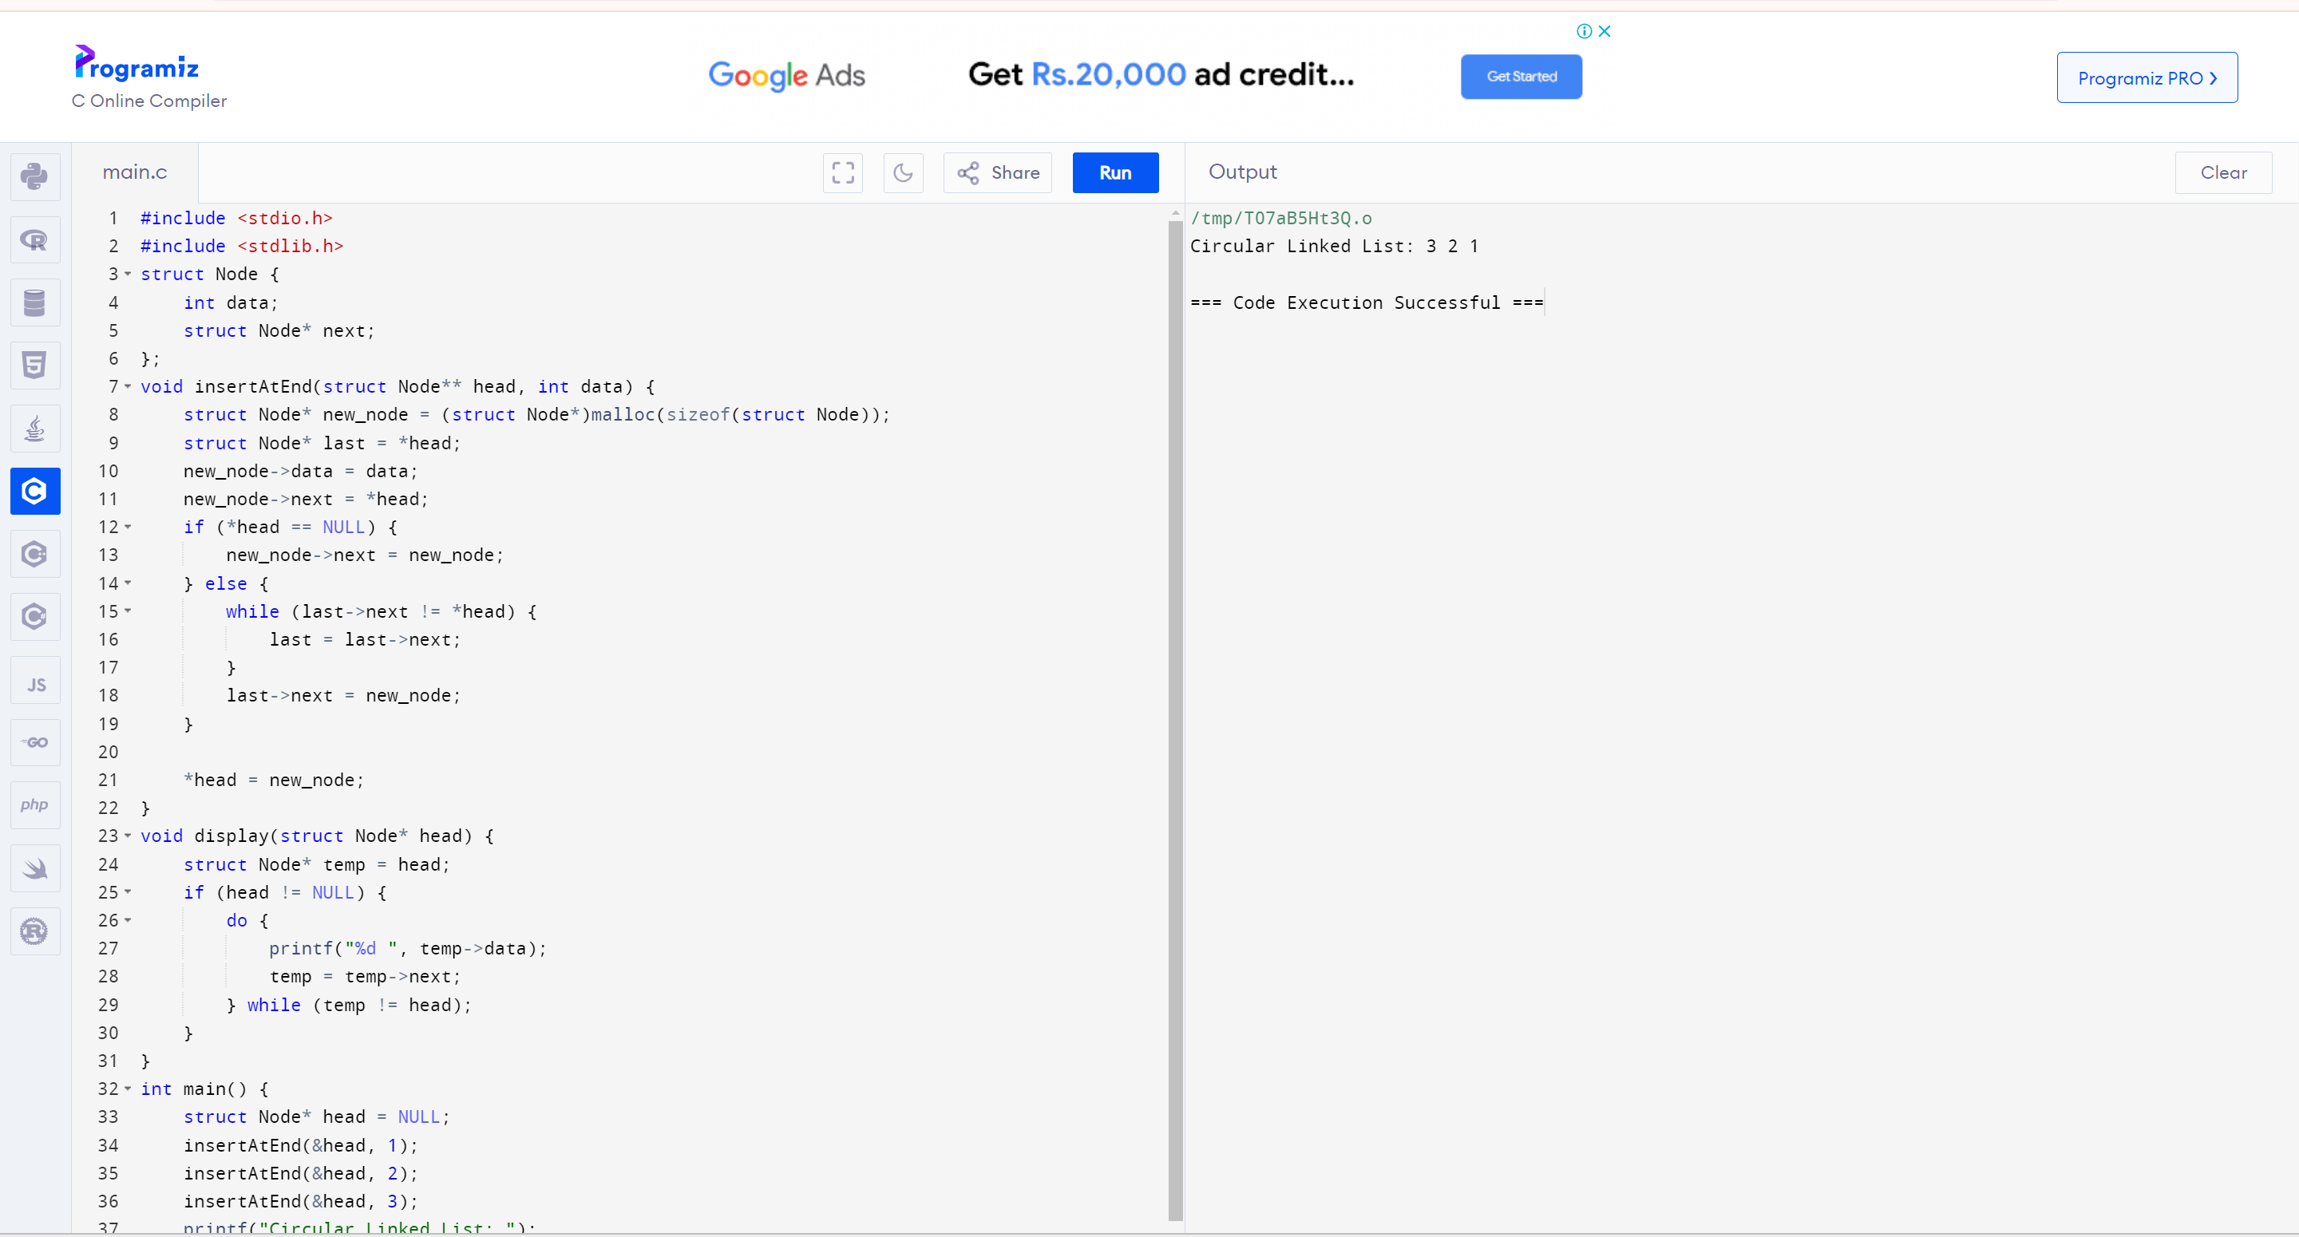

**5.Write a c program for stack operation:**

**A.Push operation**

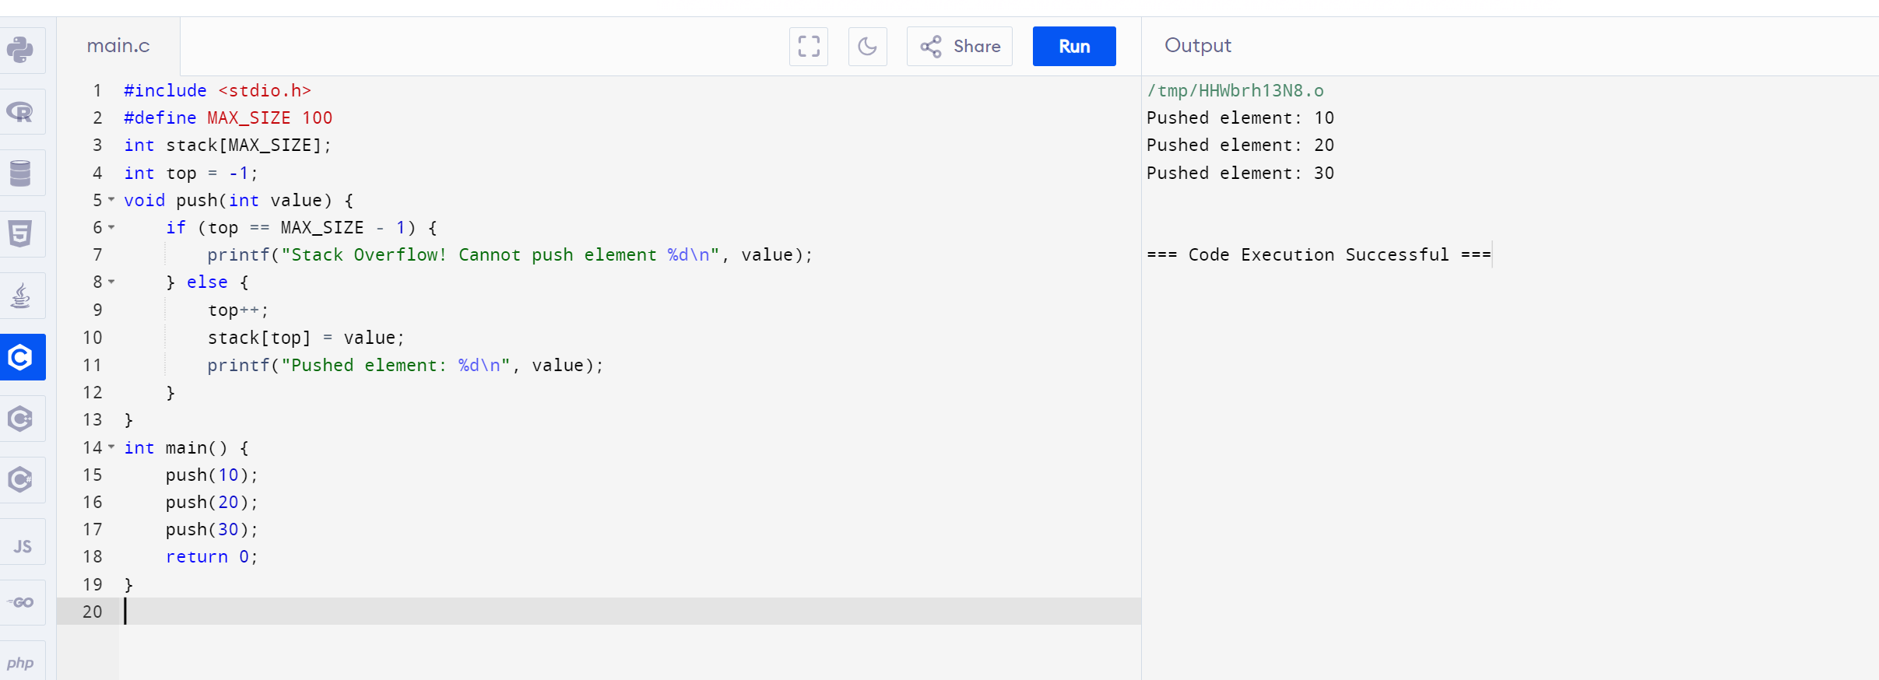

**B.Pop operation**

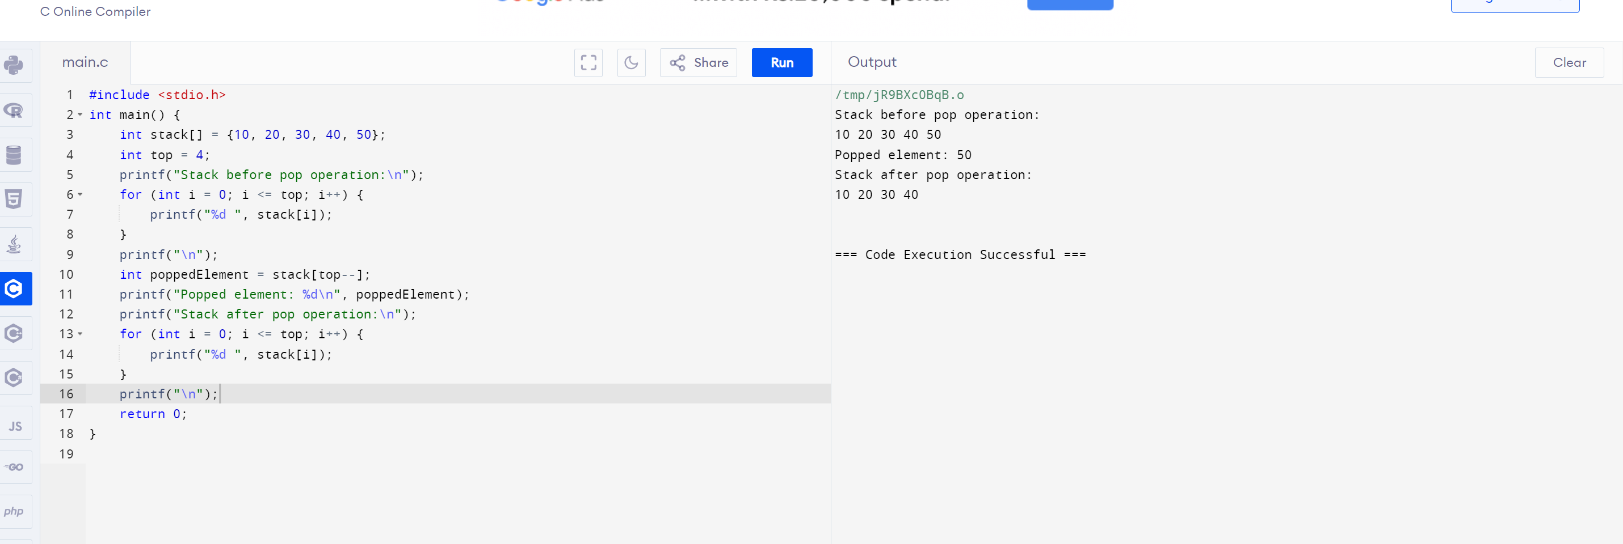

**C.Peek operation**

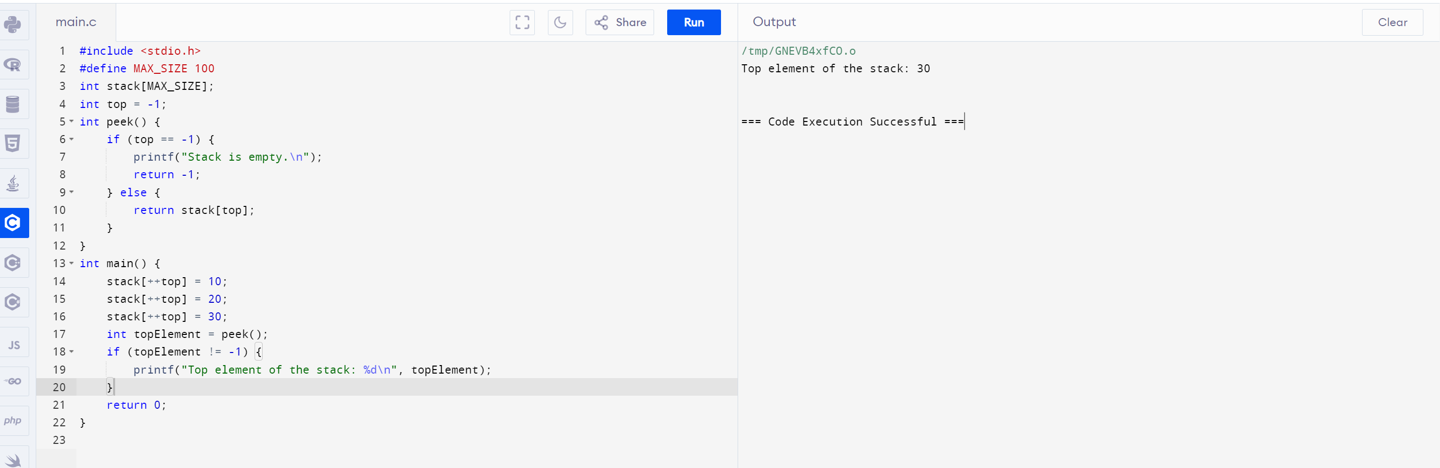

**D.Full empty operation**

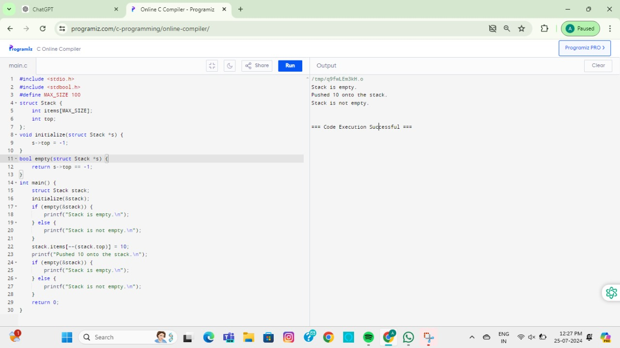

**6.Write a c program for array implementation of stack**

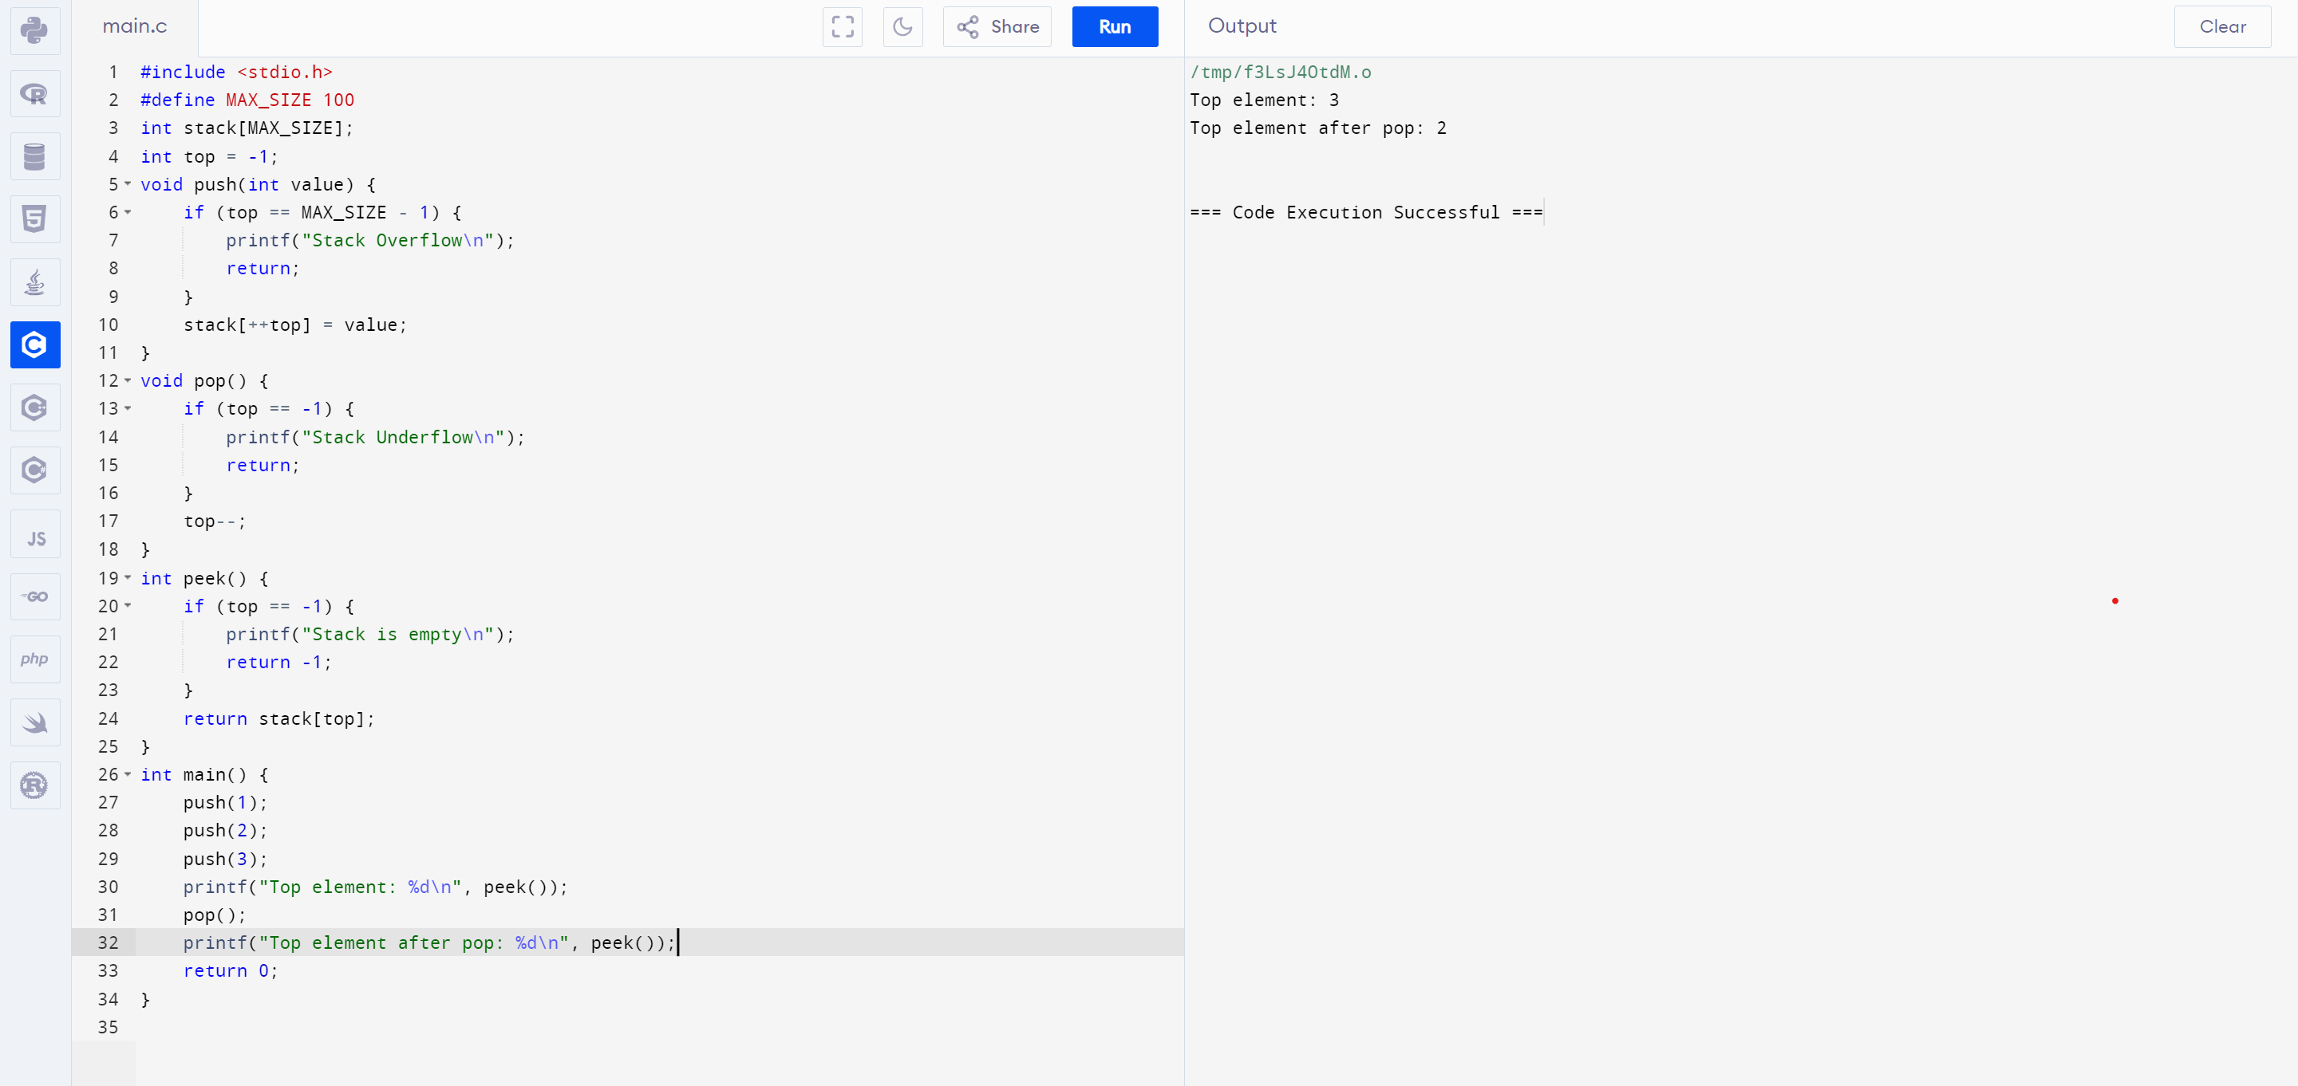

**7.Write a c program for linked list implementation of stack**

